|  |  |
| --- | --- |
|  |  |
| WORKSHOP 3 |  |
|  |  |
|  | 26/06/20Software Engeneering 2 |
|  | Parra Tarira EfrenLoor Porro RenzoDurango DavidAlvarez Alvarado Edmundo |

|  |  |  |  |
| --- | --- | --- | --- |
| **Report** |  |  |  |

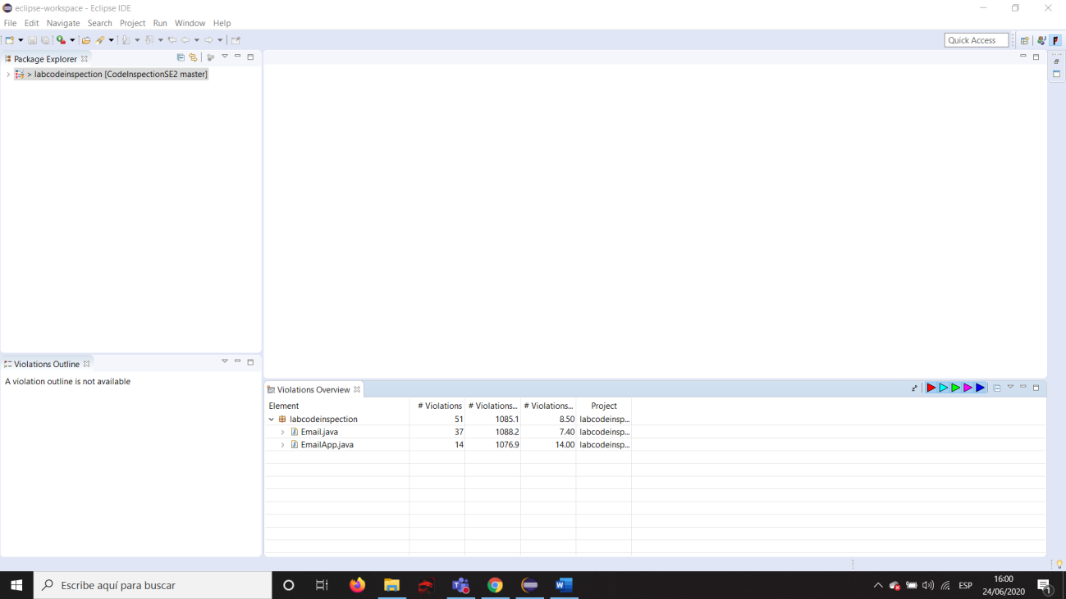

After checking with PMD.

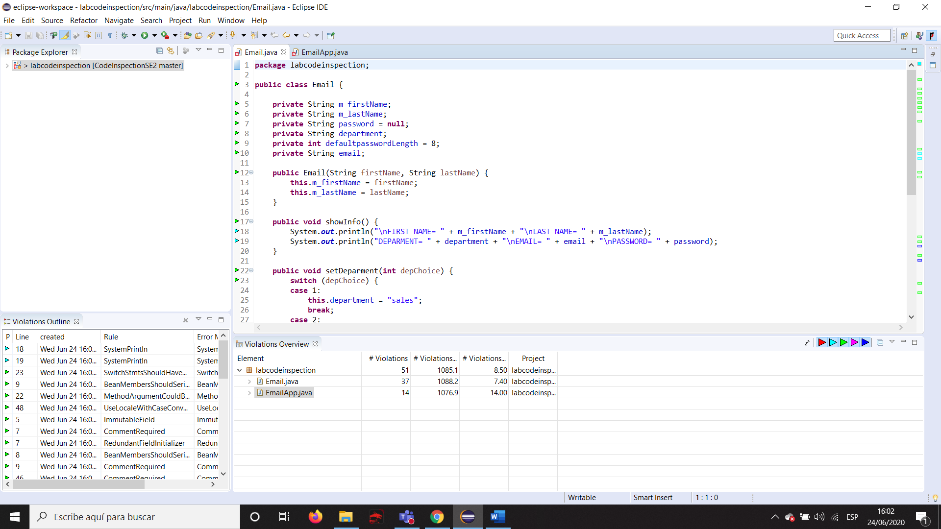

Checking code with PMD.

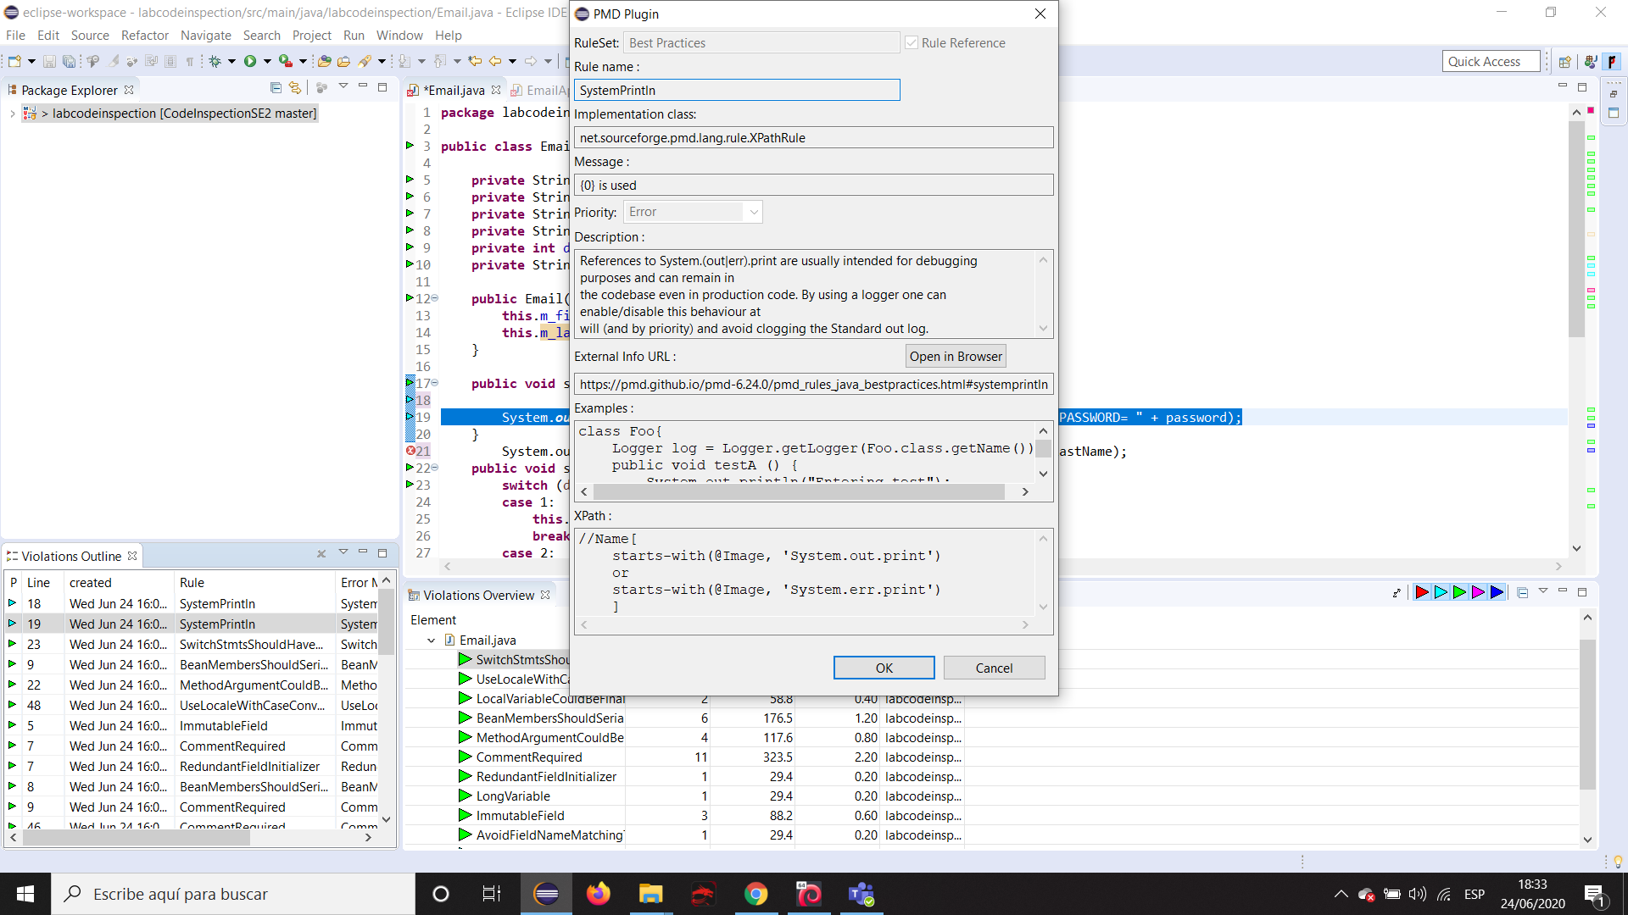

Details of a critical violation.

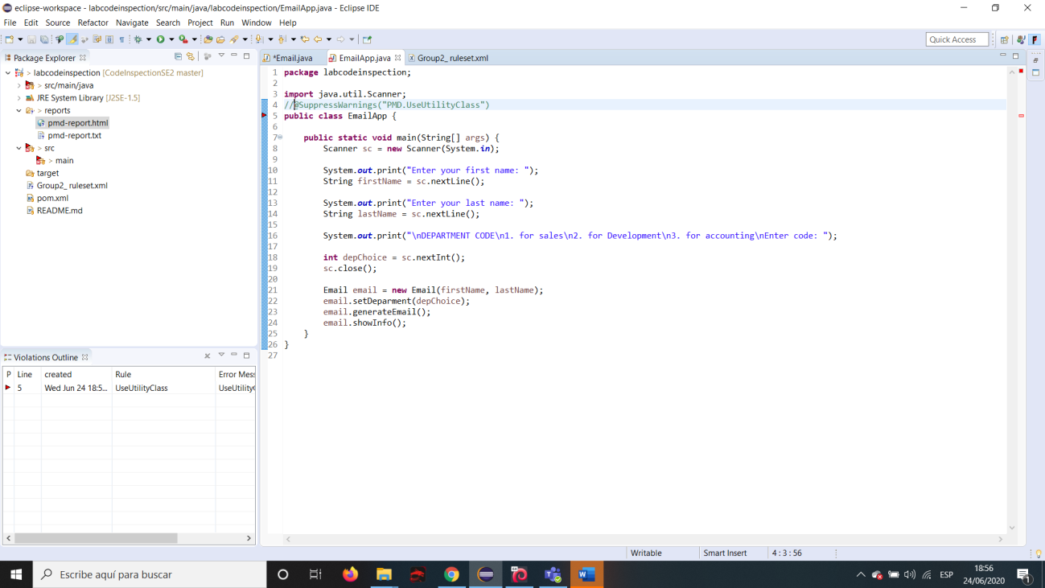

Before suppressing warning.

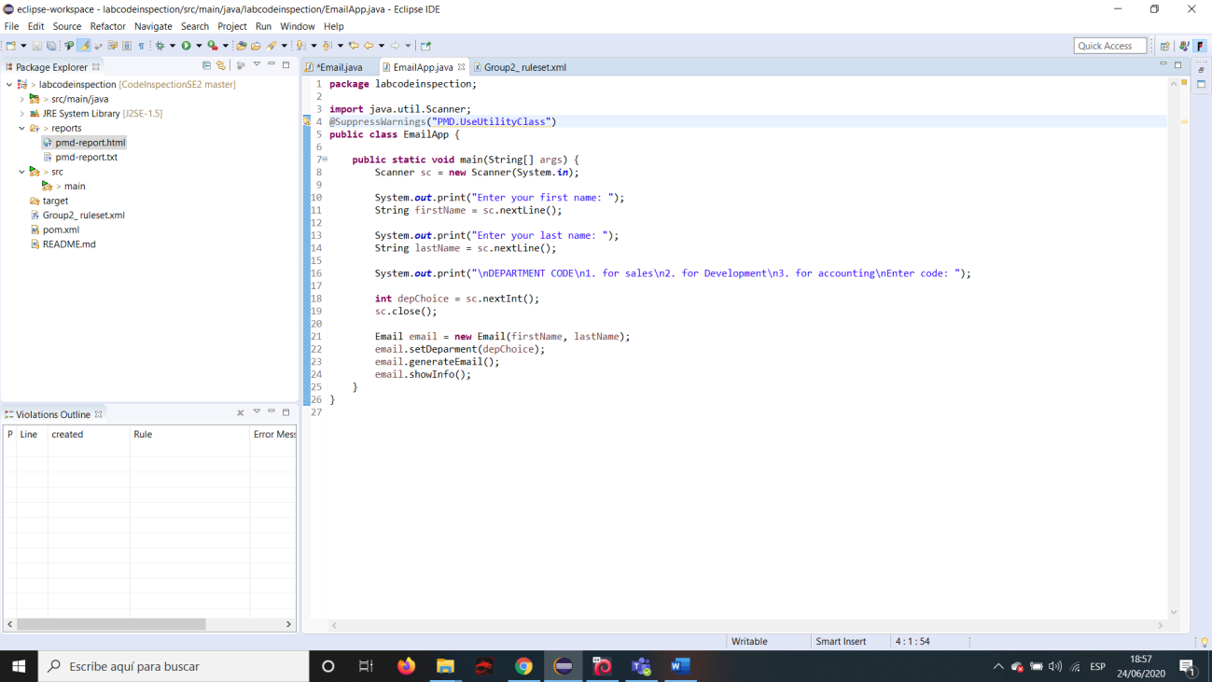

After Suppressing Warning.

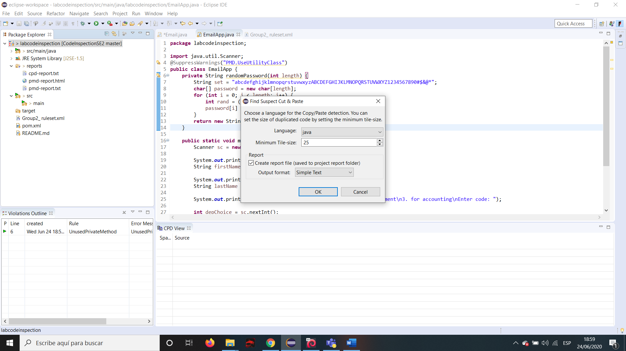

A cut and paste suspect found.

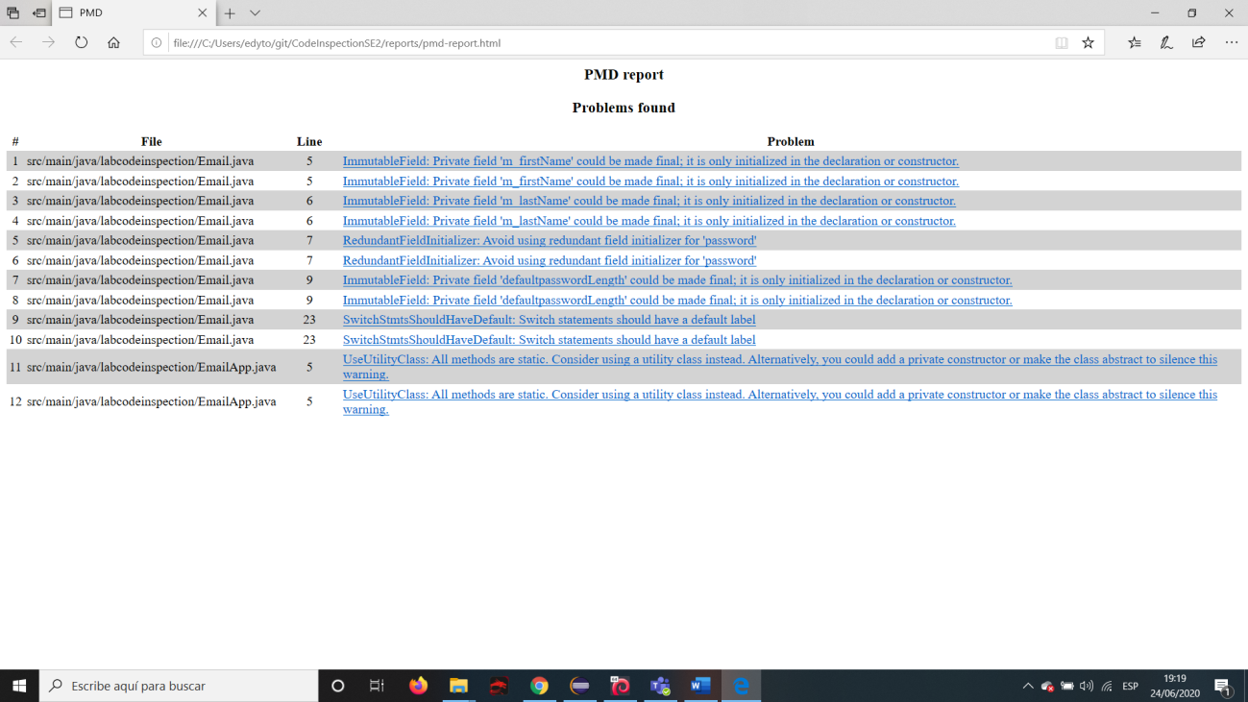

PMD Report.

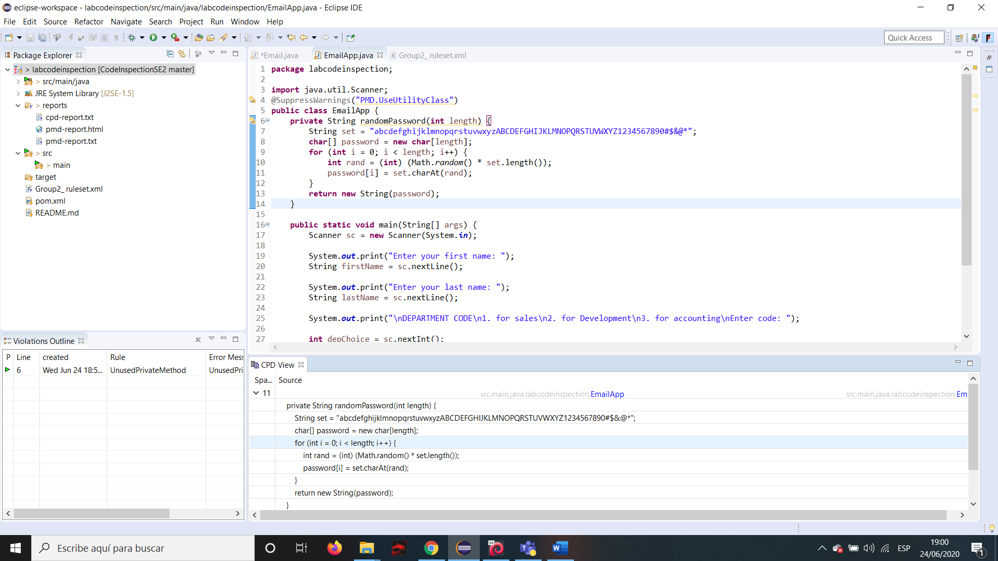

A cut and paste suspect found.

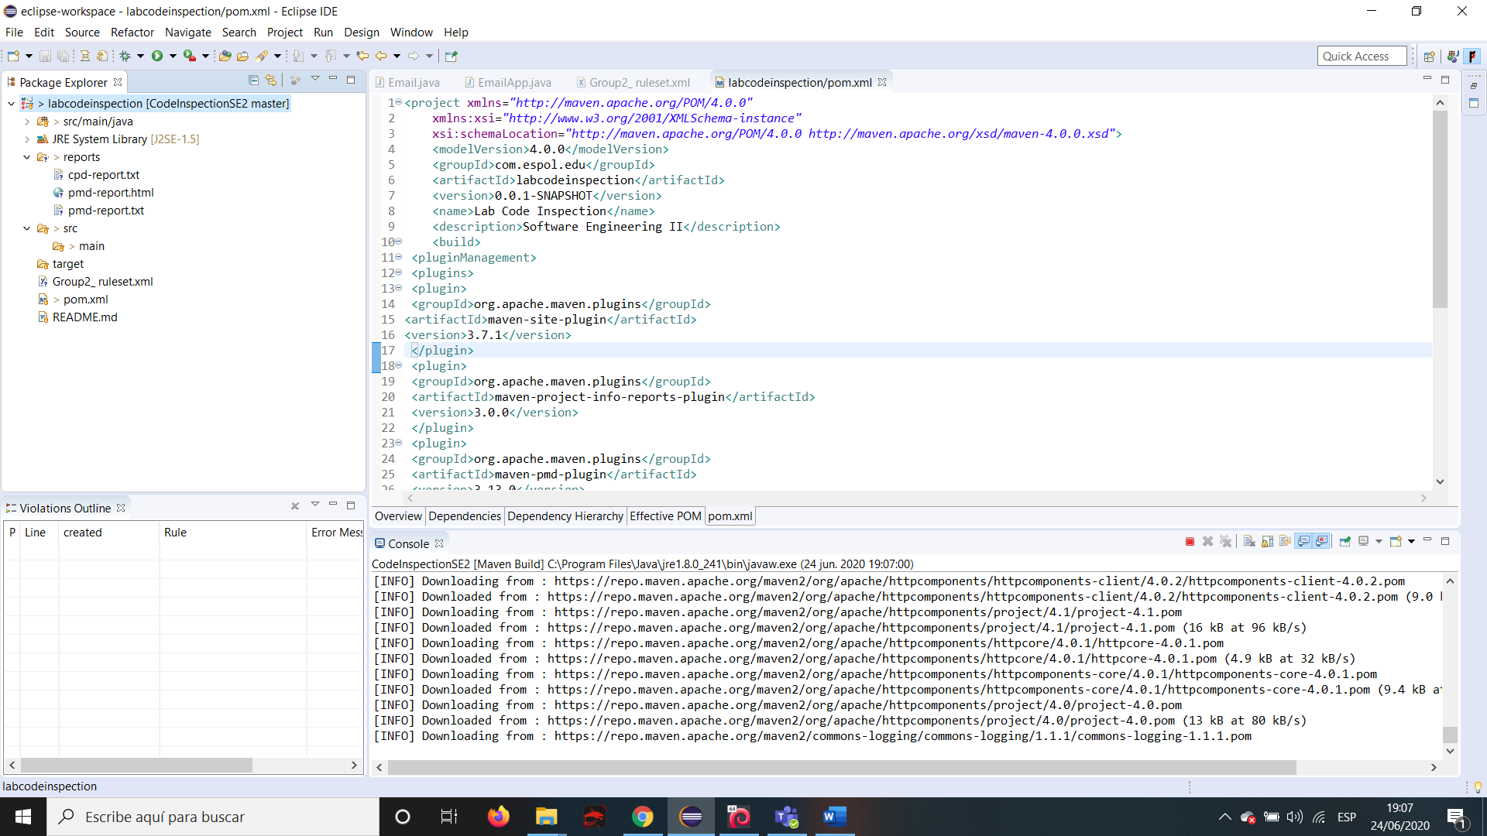

Installing necessary plugins

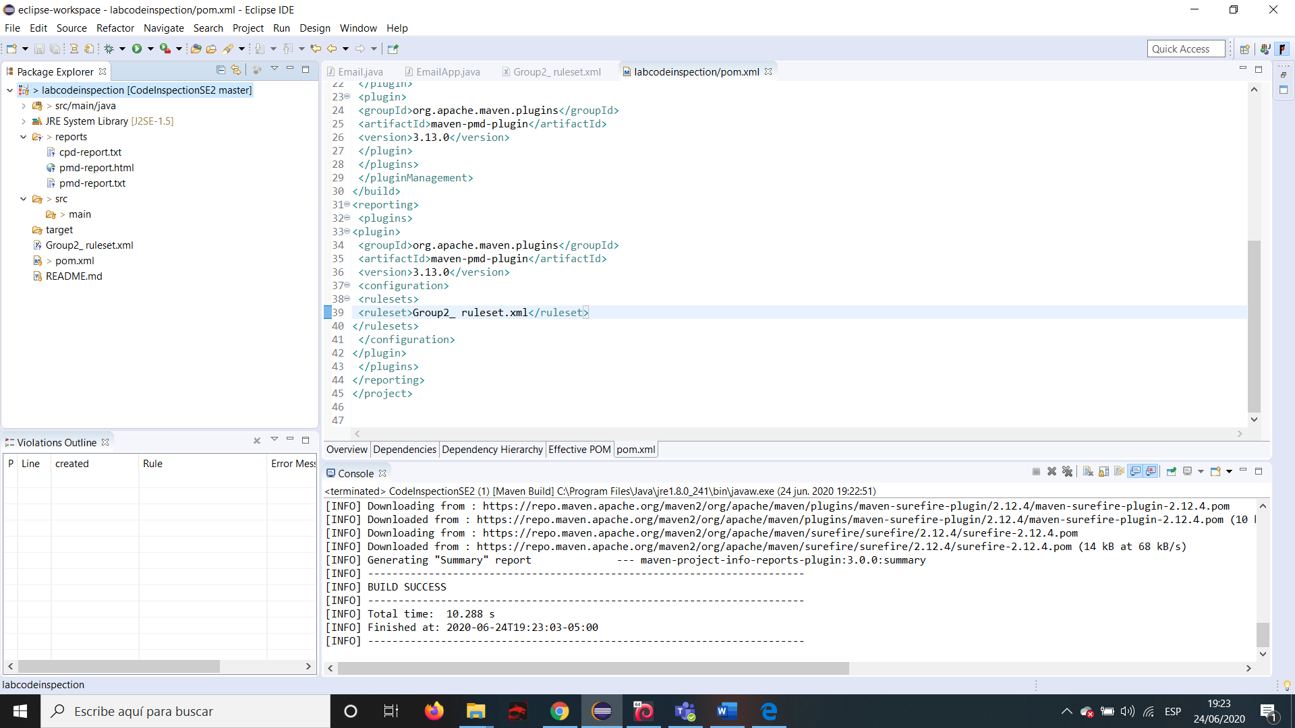

As maven run.

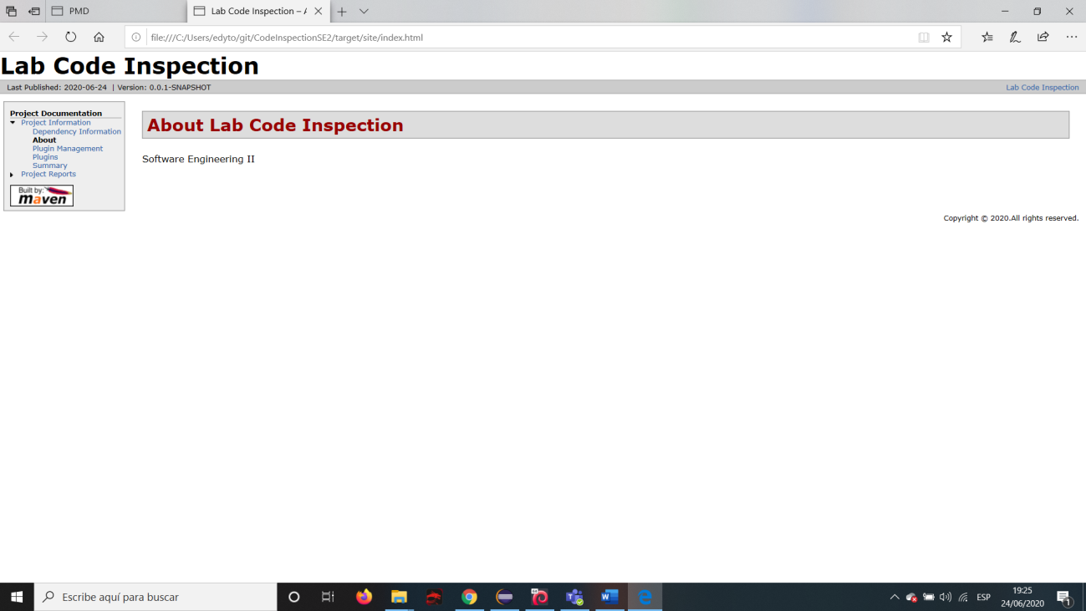

Index.html.

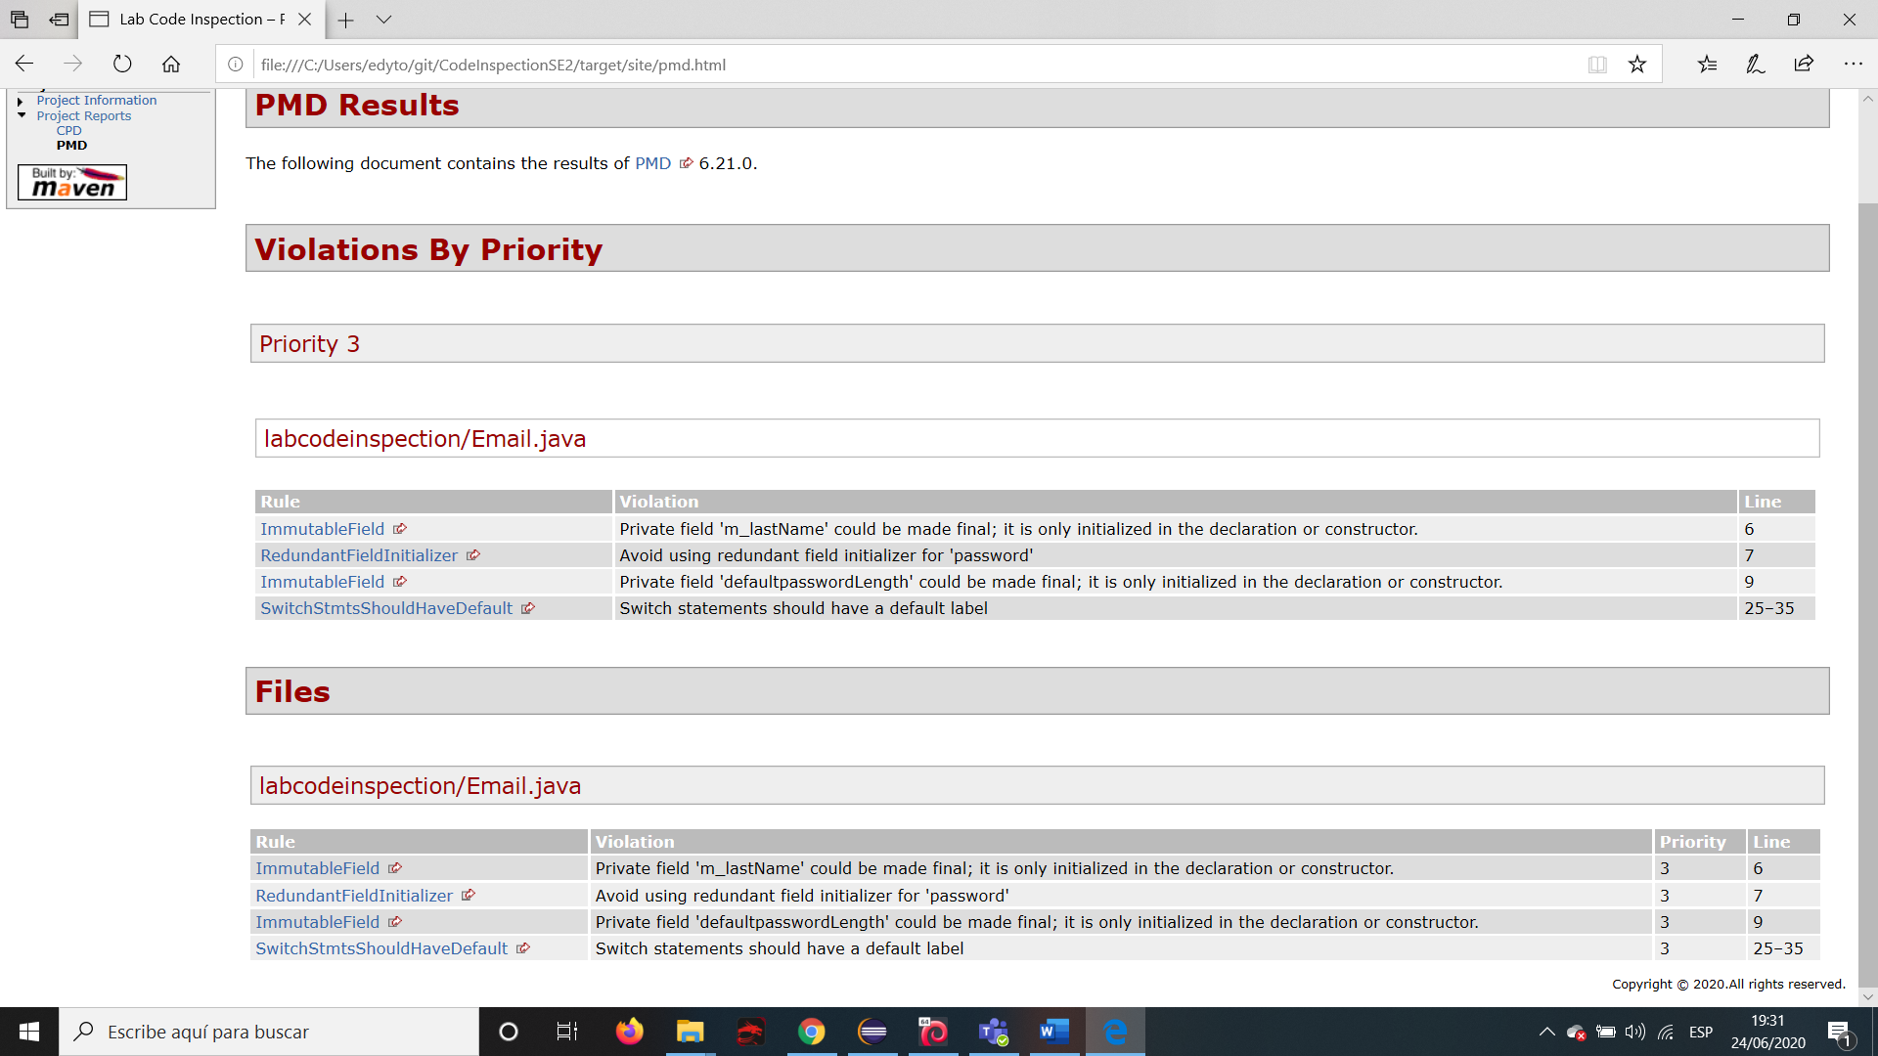

PMD Results.

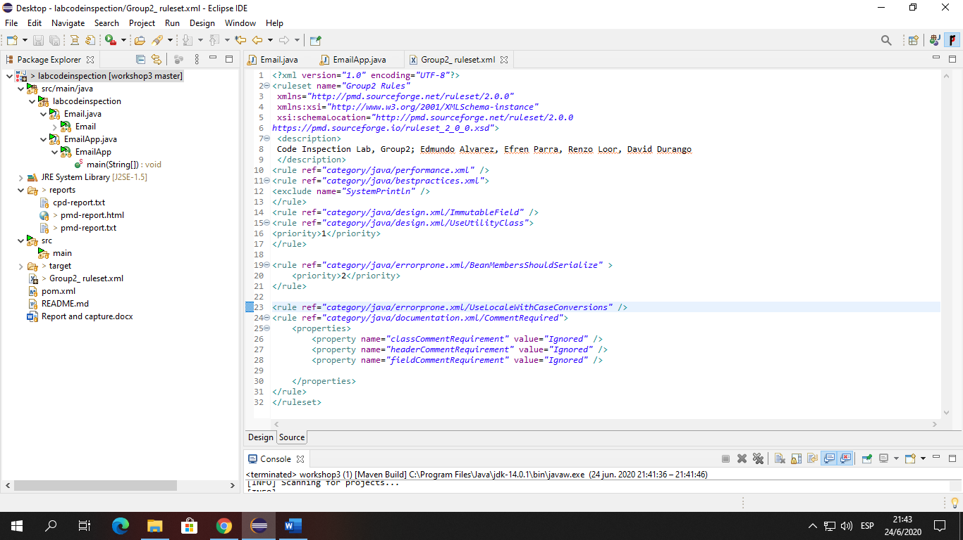

Adding new rules.

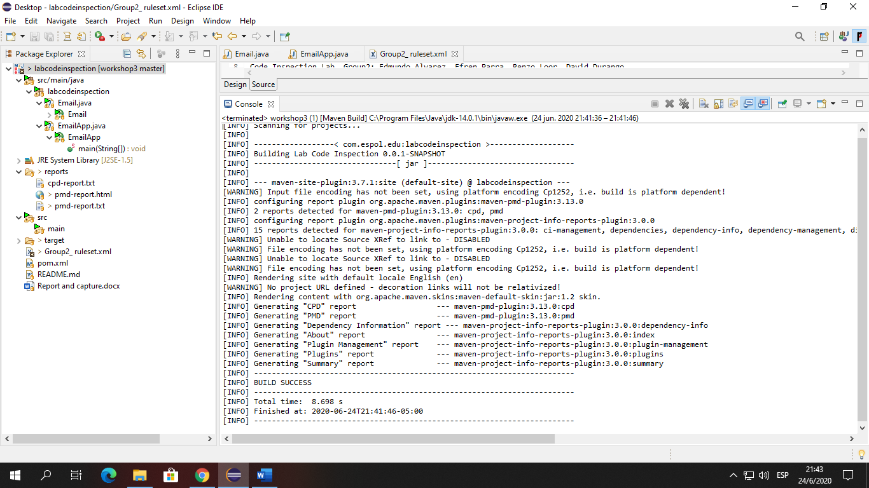

Re-Build project and generate Report.

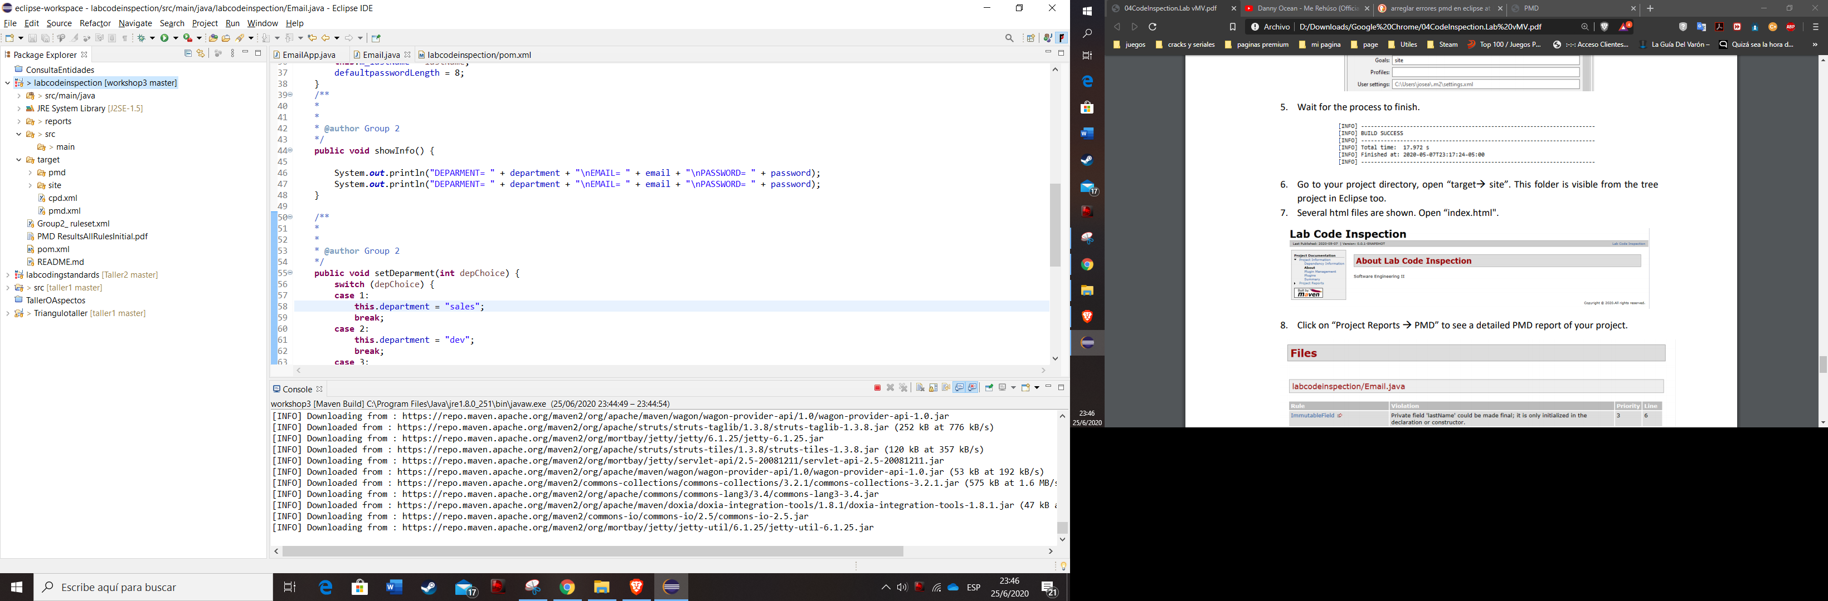

Re-building report without errors.

**Reports**

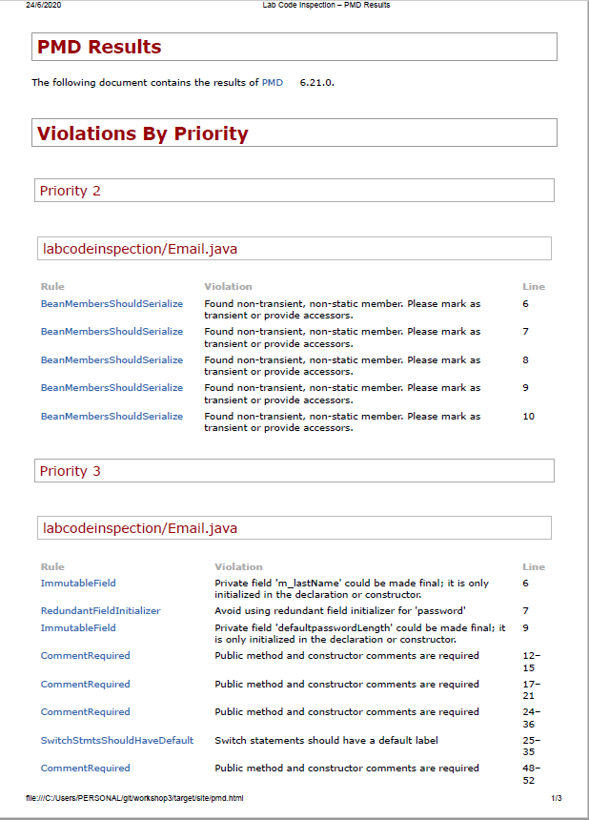

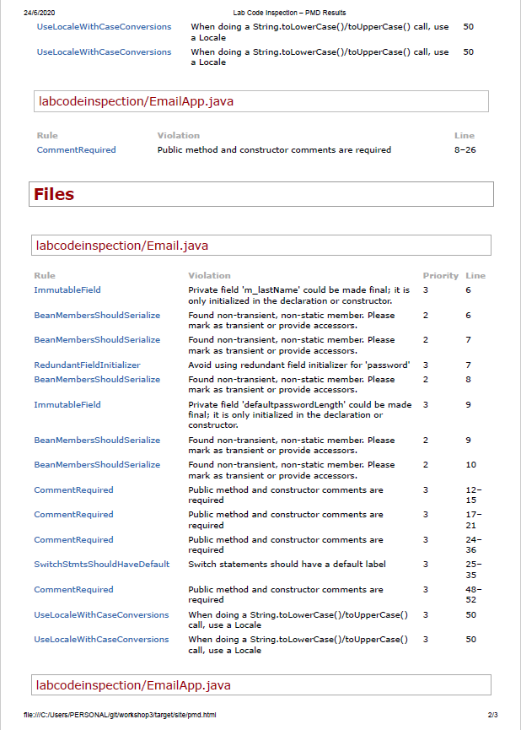

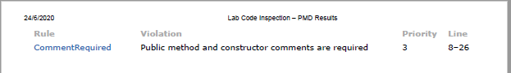

Report with errors

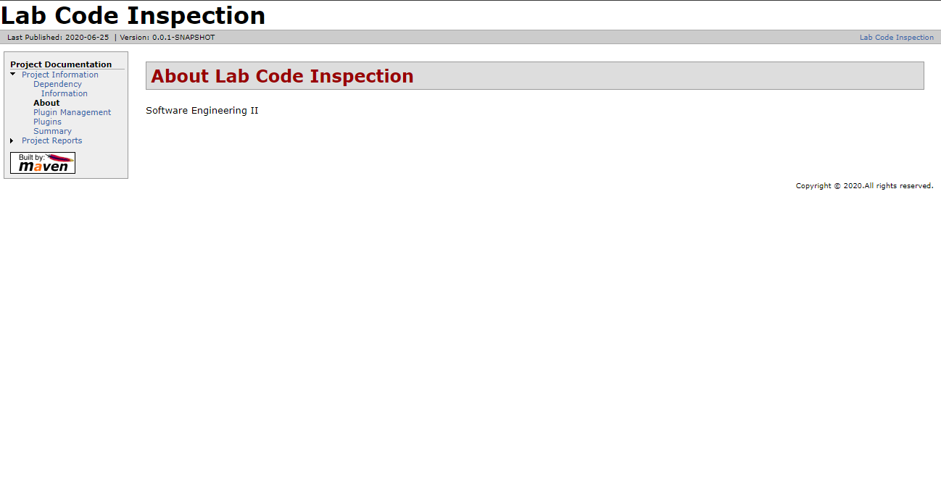

Report without errors.

**Link**

**Repository:** [**https://github.com/GrupoTwo/workshop3.git**](https://github.com/GrupoTwo/workshop3.git)